**School Name: Seth Anandram Jaipuria School**

**Session 2022-23**



PYTHON

PROGRAMMING FILE

**SUBMITTED TO: SUBMITTED BY-**

**NAME: Aditya Dang**

**CLASS: XI-E**

**ROLL NO: 03**



Scan the Qr code for Digital preview

**LIST OF PRACTICALS:**

1) WAP to program to check whether the string is Palindrome or not.

2) WAP to reverse words in a given String in Python with out using function.

3) WAP to remove i’th character from string in Python

4) WAP to find length of a string in python without using any function.

5) WAP to print even length words in a string

6) WAP to convert in Uppercase Half String

7) WAP to capitalize the first and last character of each word in a string

8) WAP to check if a string has at least one letter and one number

9) WAP to check the strings which contains vowels and print the missing vowels

10) WAP to remove all duplicates character from a given string

11) WAP to arrange the elements of a list in decreasing order of their value.

12) WAP to read a number from the keyboard and check whether the entered number is present or not in the list. If present, then also print the occurrences of an entered number.

13) WAP to find out the average of n elements in list.

14) WAP to find out the total number of even elements in the list.

15) WAP to suppress all zero elements at the bottom of the list.

16) WAP to return the largest even number from the list, if there no even number in the input, print “Even not found in the list”.

17) WAP to find the sum of even indexed elements from the list.

18) WAP to take in the roll number, name and percentage of marks for n students of Class XI and do the following:

a) Accept details of the n students (n is the number of students).

b) Search details of a particular student on the basis of roll number and display result.

c) Display the result of all the students.

d) Find the topper amongst them.

e) Find the subject toppers amongst them.

19) WAP to create a list with some duplicate values and remove all the duplicates from the list.

20) WAP to print a specified list after removing the 0th, 3rd and 5th elements.

Example: [2,3,4,5,6,7,8] then output will be [3,4,6,8]

21) WAP to iterate over dictionaries using for loops.

22) WAP to generate and print a dictionary that contains a number (between 1 and n) in the form (x, x*x).

Sample Dictionary ( n = 5) :

Expected Output: {1: 1, 2: 4, 3: 9, 4: 16, 5: 25}

23) WAP print a dictionary where the keys are numbers between 1 and 15 (both included) and the values are the square of the keys.

Sample Dictionary

{1: 1, 2: 4, 3: 9, 4: 16, 5: 25, 6: 36, 7: 49, 8: 64, 9: 81, 10: 100, 11: 121, 12: 144, 13: 169, 14: 196, 15: 225}

24) WAP to merge two Python dictionaries.

25) WAP to multiply all the items in a dictionary.

26) WAP to map two lists into a dictionary.

27) WAP to sort a given dictionary by key.

28) WAP to get the maximum and minimum values of a dictionary.

29) WAP to remove duplicates from the dictionary.

30) WAP to combine two dictionaries by adding values for common keys.

31) Write a Python program to find the highest 3 values of corresponding keys in a dictionary.

32) Write a Python program to combine values in a list of dictionaries.

Sample data: [{'item': 'item1', 'amount': 400}, {'item': 'item2', 'amount': 300}, {'item': 'item1', 'amount': 750}]

Expected Output: Counter ({'item1': 1150, 'item2': 300})

**Outputs of the Questions:**

1.

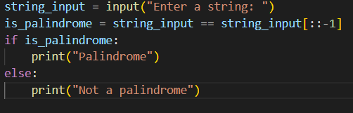

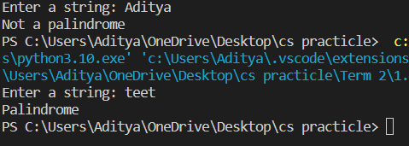

2.

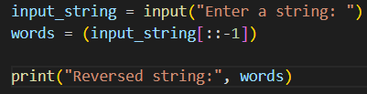



3.

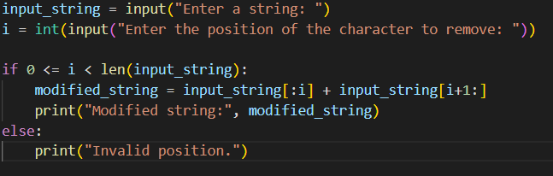



4.

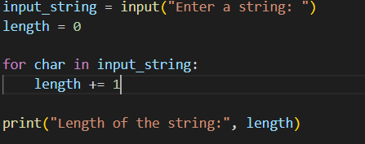



5.

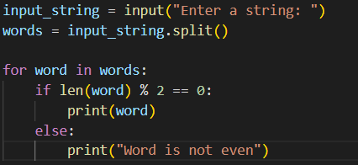

6.

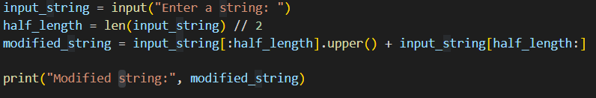



7.

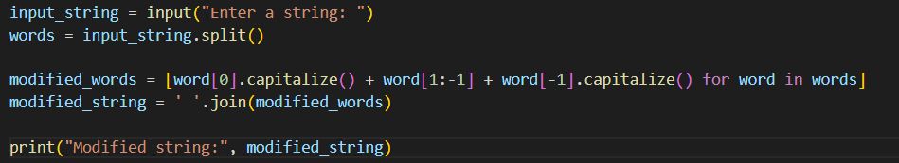



8.

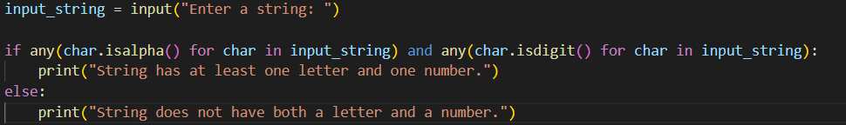

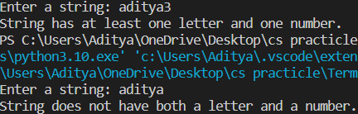

9.

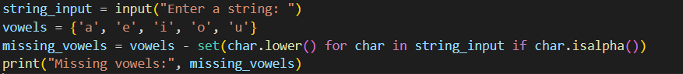



10.

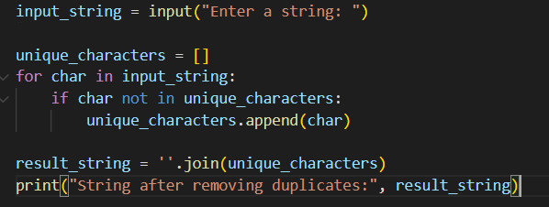



11.

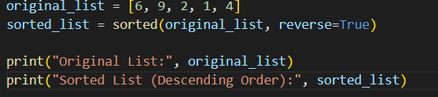



12.

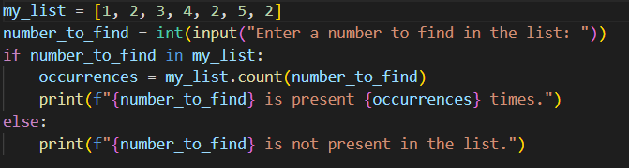



13.

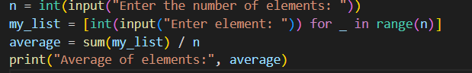

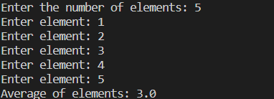

14.

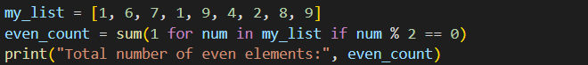



15.

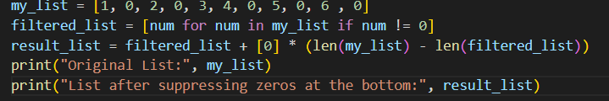



16.

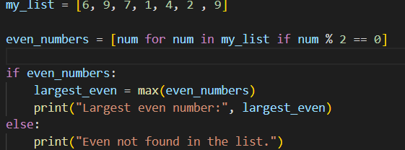



17.

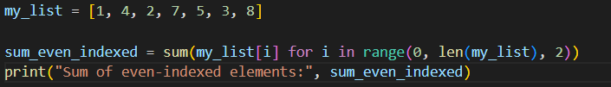

18.

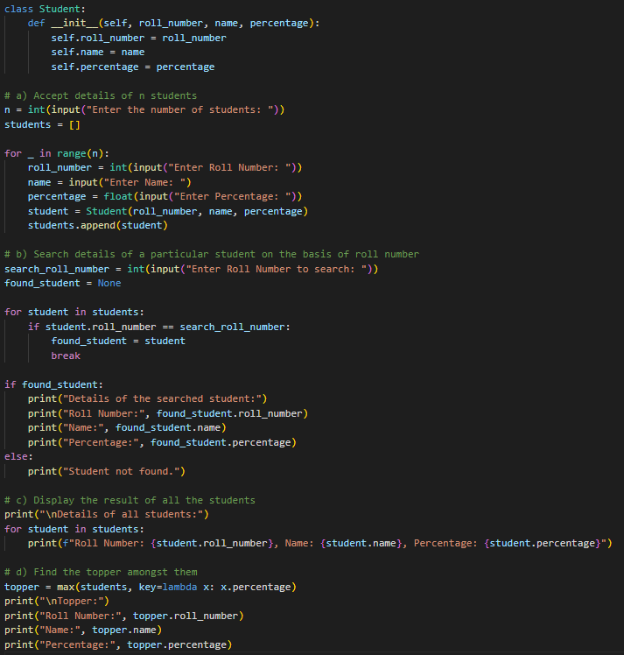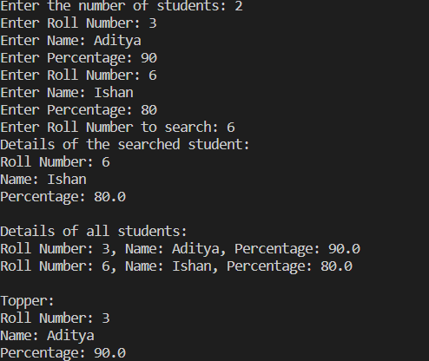

19.

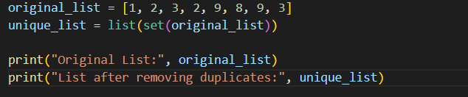

20.

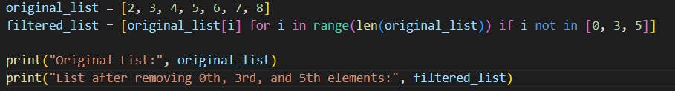

21.

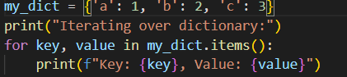 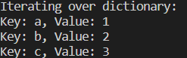

22.

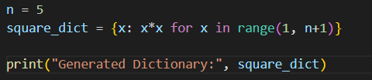

23.



24.

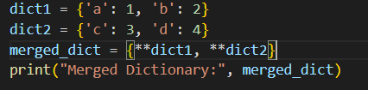 

25.

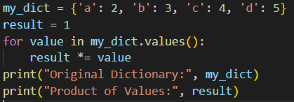 

26.

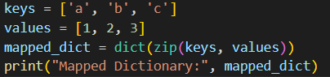 

27.

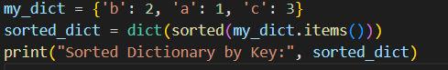 

28.

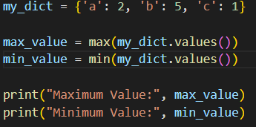

29.

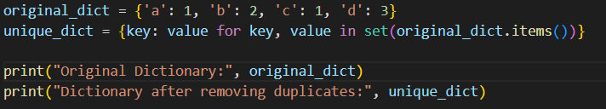

30.

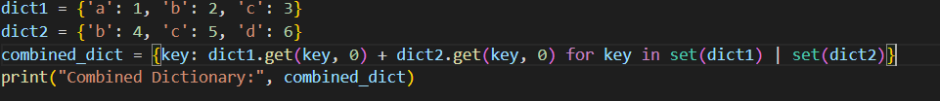

31.

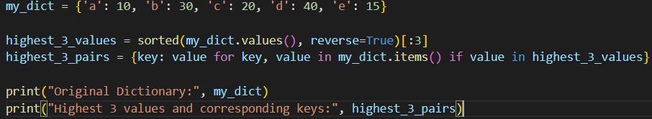



32.

